“Star of the Youth”
International Trenchless Technology Conference
______________________________________________________

Qingdao, Shandong, China
10th-12th April 2020

Paper Ref #
(the paper ref# will be supplied to authors)

TITLE OF PAPER

A. Author¹ , B. Author²*, ...

¹ Department 2, University, Area code, Street address, Country
² Department 2, University, Area code, Street address, Country
*email@email.em

ABSTRACT: This set of instructions follows the required format of papers for the conference. This page is a sample first page of the paper. The next page is a sample of all subsequent pages. The completed paper shall not exceed 10 pages using Times New Roman 10 font, 25mm (1 in.) margins all around. Author(s) are required to submit an electronic file document in the .doc or .docx format of the full paper(s) for peer review and comment. Please compress the files when saving, especially if there are photos included.

The heading appearing on the first page of the paper should include the “Star of the Youth” and International Trenchless Technology Conference logos and the title of the conference as shown on this page. Authors must use this template for the preparation of paper.

Abstracts should be limited to 300 words maximum.

Provide 4 Blank lines between Abstract & Introduction

1. INTRODUCTION (main body of paper should begin immediately after the Abstract)

The Conference Proceedings will be prepared from an electronic file document (pdf format) supplied by the author(s). To ensure publication quality and uniformity, the following requirements have been prepared to assist authors in preparing papers for the Conference. If these requirements are not followed, papers will be returned for revision and re-submittal. The resulting time delay could cause rejection of the paper because of publication deadlines for the Conference Proceedings.

2. PAGE NUMBERS

Each paper will be assigned a number in the electronic conference proceedings. To facilitate printing and further referencing, local page numbering is used in each paper, starting from page 1. The page number should appear centered as a footer.

Sample: Paper Ref# - 1 # is the paper number that will be assigned to you in an automated email and “1” is the first page

3. EQUATIONS, FORMULAS, SYMBOLS AND UNITS

Center all equations and formulas and number them consecutively. Refer to equations in the body of text by these numbers (e.g. “Eq.1” or “Equation 1 shows…”). Use imperial or metric units and Arabic numerals. Use of units must be consistent throughout the paper.

[1]

4. ILLUSTRATIONS

Number illustrations (whether drawings or photographs) consecutively in the order of appearance and refer to them as Figure 1, Figure 2 to 4, etc. Avoid placing illustrations sideways on a page; however, if this is not possible, no other text should appear on that page (Najafi, 2003). Photographs should be of good quality contrast. Figure lettering should be approximately the same size as the text with a minimum of 10 point font. Make sure that illustrations borrowed or adapted from another source are properly acknowledged.

Captions should be placed immediately below the illustration.

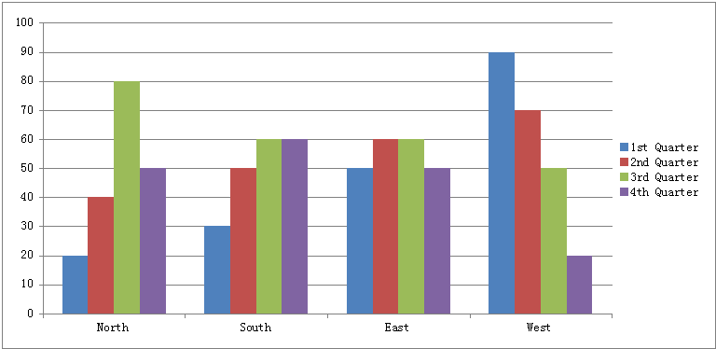

Figure 1. Guidelines for No-Dig Show 2010: sample figure and positioning of the legend

5. TABLES

Number tables consecutively in order of appearance and place them as close as possible to where they are first referenced in the text. Refer to tables as Table 1, or Tables 1 and 2, in the body of text. Avoid abbreviations in column headings (other than units). Indicate units in the line immediately below the heading. Type the caption above the table to the same width as the table and leave one line space between the table caption and the table.

Table 1. Sample table for the as explained in the requirements for papers

Title | Sub-title (units) | Sub-title (units)
Line 1 | 1234 | 4321
Line 2 | 1321 | 8765

6. REFERENCES (in alphabetical order)

Gokhale, S., and Ariaratnam, S. (2002). Life Cycle Modeling of Sewer Infrastructure, Journal of No-Dig Engineering, Volume 3, No. 2, pp. 33-42.

Najafi, M. (2003). Educational needs in Trenchless Technology. Proceedings of 2003 No-Dig Show, Las Vegas, Nevada, March 31-April 2, 2003.

